**Article ID:** [4220] Discoloration of silver or aluminium objects

**Article Name:** Discoloration of silver or aluminium objects

**Topic Location:**  Dishwasher / Usage / Poor results

**Metadata:**

**Related Articles:**

**Related Questions:**

PNC

DIY

Safety

Link

Email

Book Engineer

Multimedia

Brand

**Article Content:**

**WSS**

Aluminium and silver can become black from air, sulphur and water. When these objects are washed, black marks can be left on other objects in the load and the baskets. Some silver objects only have a thin layer of silver and so cannot be washed in the dishwasher. These objects must therefore not be placed in the dishwasher.

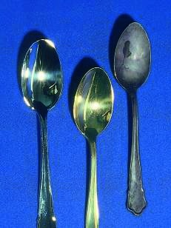

http://services.electrolux-medialibrary.com/bild.php?src=ehppdb-pictures/G/B/JPEG/PSGBDL140G002005.jpg

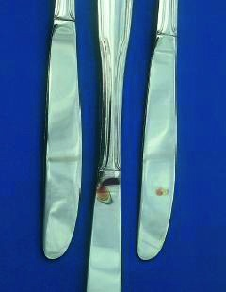

http://services.electrolux-medialibrary.com/bild.php?src=ehppdb-pictures/G/B/JPEG/PSGBDL140G002004.jpg